Characteristics of Family-Run Businesses in India and the UK- Analysing Succession Planning (Competency vs. Relationships) for Business Success and Profitability

Abstract
The study explores the working of a family business both in India and the UK to understand the role played by family members in family business. Generally, in family business organisations family people get managerial positions based on their relationships rather than competency. The aim here is to explore whether this phenomenon is true or not and to what extent such decisions have implications of family business profitability.

The current literature talks about the governance and management in family business wherein control of the organisation is passed through generations of family members. The available literature fails to identify whether family business have succession plans in place and how these plans support competency development in family and non-family members. In order to test this a comparative analysis between two successful family business one hailing from each India and the UK is made to derive comprehensive results in an international setting.

For achieving this research objective, a mixed method will be used wherein a survey of employees (quantitative data analysed using SPSS) and interview of family members (qualitative data analysed descriptively) has been executed. The findings reveal that top management and leadership positions are retained by the family members and there is no appropriate succession planning approach in both the countries. It has also been found that irrespective of this the companies believe in competencies of people which is evident from their success quotient. Based on the findings it is recommended that family business organisations should have appropriate succession plans and design competency development programs for all organisational members irrespective of their family relationships to support long run profitability and business success.

Total Words: 9613

Table of Contents
Abstract 2
List of Tables 6
List of Figures 7
Definitions, abbreviations and glossary 8
Chapter 1: Introduction 9
1.1 Background of the study 9
1.2 Introduction to the case companies: Reliance Industries Limited and Swire Group 10
1.3 Problem Statement 10
1.5 Research aims and objectives 10
1.6 Research Questions 11
1.7 Significance of the study 11
1.8 Chapter Outline 11
Chapter 2: Literature Review 13
2.1 Chapter Introduction 13
2.2 Characteristics of Family Run Businesses in India and the UK 13
2.3 Need for Succession Planning and Factors influencing Succession Planning in Family Run Businesses 16
2.4 Competency vs. relationship in succession 18
2.5 Role of managers in family business success/ profitability 20
2.5 Chapter Summary 21
Chapter 3: Research Methodology 23
3.1 Chapter Introduction 23
3.2 Research Philosophy, Approach and Strategy 23
3.2.1 Philosophy 23
3.2.2 Approach 23
3.2.3 Strategy 24
3.3 Sampling, Data Collection and Analysis 24
3.3.1 Sampling 24
3.3.2 Data Collection 24
3.3.3 Data Analysis 25
3.4 Ethical Issues and Limitations 26
3.4.1 Ethical Aspects 26
3.4.2 Limitations 26
3.5 Chapter Summary 26
Chapter 4: Data Analysis 27
4.1 Chapter Introduction 27
4.2 Quantitative Analysis 27
4.2.1 Reliability Test 27
4.3.2 Demographic Analysis 28
4.3.3. Company Overview 31
4.3.4 Competency Vs. Relationship 33
4.3.5 Recommendations and other comments 42
4.3.6 Inferential Analysis 44
4.3 Qualitative Analysis 48
4.3.1 Theme 1: Competency Vs. Relationship 49
4.3.2 Theme 2: Successorship for family members for ensuring organisational success and profitability 49
4.4 Chapter Summary 50
Chapter 5: Discussions, Conclusions and Recommendations 51
5.1 Chapter Introduction 51
5.2 Discussions and Conclusion 51
5.3 Recommendations 52
5.4 Chapter Summary and Scope for Future Research 53
Annexure 54
Annexure 1: Quantitative Questionnaire 54
Annexure 2: Interview Schedule 56
References 58

List of Tables
Table 1 Reliability Tests 22
Table 2 Age Analysis 23
Table 3 Gender Analysis 24
Table 4 Experience within the Company Analysis 25
Table 5 Top Management Composition 26
Table 6Educational Qualification of Managers 27
Table 7 Domination of Family Members in Top Management 28
Table 8 Decentralised Decision Making 29
Table 9 Competency Over Relationships 31
Table 10 Relationships Over Competencies 32
Table 11 External Employee Competency Development 33
Table 12 Family Member Competency Development 34
Table 13 Leadership by Family Members 35
Table 14 Succession Planning for Profits and Success 36
Table 15 Suggestions 38
Table 16 Model Summary 40
Table 17 Anova Table 41
Table 18 Coefficient Table 42
Table 19 Excluded Variables 43
Table 20 Manager Respondent Profile 44

List of Figures
Figure 1 Characteristics of a Family Business 10
Figure 2 10 commandments of family Business 11
Figure 3 Age Analysis 25
Figure 4 Gender Analysis 26
Figure 5 Experience within the Company Analysis 27
Figure 6 Top Management Composition 28
Figure 7 Educational Qualification of Managers 29
Figure 8 Domination of Family Members in Top Management 30
Figure 9 Decentralised Decision Making 31
Figure 10 Competency Over Relationships 32
Figure 11 Relationships Over Competencies 34
Figure 12 External Employee Competency Development 35
Figure 13 Family Member Competency Development 36
Figure 14 Leadership by Family Members 37
Figure 15 Succession Planning for Profits and Success 38
Figure 16 Suggestions 40

Definitions, abbreviations and glossary
CGMA – Chartered Global Management Accountant
FFI - Family Firm Institute
GDP - Gross Domestic Product
KPMG - Peat Marwick International (PMI) and Klynveld Main Goerdeler (KMG) combined together
OECD - Organisation for Economic Co-operation and Development
PWC – PriceWater House Coopers
UK - The United Kingdom

Chapter 1: Introduction

Background of the study
Family owned businesses are the forte of many economies all around the world. However, budding development and globalization have created many challenges for family businesses. Family-owned establishments are characterised as institutions in which the stakeholders come from the same family and donate noticeably in the supervision, direction, and running the company (Gulzar & Wang, 2010).
The report by CGMA (2012) enumerated the prominence of a family business in the economy stating that they are as crucial as demand and supply all across the globe. In India, the range of family managed and owned businesses have expanded to incorporate some of the ecosphere’s major businesses and their monetary weight remains massive. In all economies, family-owned businesses hold the greater part of the economy and in relations of accounts of specific ingenuities, they account for a considerable percentage of GDP in their markets. It has also been argued that family businesses are more systematized than other corporations for untiringly capitalising during recurrent downturns, giving them lead over other equity held establishments wherein venture tends to follow money drift more punctiliously.
In India, it has been found that Family companies contribute approximately 66% to India’s gross domestic product. Moreover, a report by KPMG (2013) in FFI (2016) also highlighted that family business also generates 79% of the organized private sector employment and 27% of the overall employment. On the other hand, In UK, the contribution of family business to the GDP of UK is 25% and 75% of the family business in the UK have processes in place to handle matters/conflict amid generations (FFI, 2016).
In a report by PWC (2013) of Family Business Survey 2012, it was discovered that family businesses are dynamic, enthusiastic and operative. Being tremendously unwavering and strategic, they are relishing solid profits even in a vague economic condition.
According to Aronoff et al. (2016), the family owned businesses have their arrangements, accountabilities, and civil liberties with their market shares and enduring trade. While operating a family commerce, the initiator of the company is in charge of long-term scheduling, lawful matters and configuration of tax.

Introduction to the case companies: Reliance Industries Limited and Swire Group
In this assignment, two companies one from a developed and developing country is considered. Reliance Industries Limited (RIL) is chosen from the developing country India and Swire Group is chosen from the developed country the UK. As mentioned by Campopiano et al. (2014), RIL is an Indian conglomerate that has its headquarters in Mumbai. The business is successfully running across India and other global countries and is engaged in petrochemicals, natural resources, energy, telecommunication and retails. The organization came into existence in 1960 and was co-founded by Dhirubhai Ambani and Champaklal Damani. This family business is successfully running across the world with nearly 25,000 employees. Cappelli, et al. (2015) stated that Swire Group is another family business, which is a British conglomerate, having it’s headquartered in London. It is a diversified global business group that has its area head offices in Asia Pacific countries, Australia, Singapore and USA. The business is globally situated and is engaged in aviation, property dealings, beverages, food chain, manufacturing, wholesale, retail, agriculture, offshore support system and mining. This family business has nearly 140,000 employees working globally, and it came into existence in 1816 by John Swire.

Problem Statement
The modest and sensitive vibrant forces fundamental to every family are amplified when a business is inserted to the mix. Suitable succession planning and selection practices are the only secret sauce for harmonising family associations and capacities with those required from outside the family ( Axiom , 2012). Family ownership may be seen as an opportunity or a liability, subject to a variety of features (OECD, 2007).
Competencies and Relationship are the two facets which plays a crucial role while undergoing a family succession planning. Though a lot of attempts have been made to explore the family business yet the little research has been done to understand criteria on which successor is being selected. This study attempts to understand whether the family business pays weight to either competency or relationship while selecting the successor and its impact on the profitability and success of the organisation. The case organization of the study are Reliance Industries Limited in India and Swire Group in the UK.

1.5 Research aims and objectives
The research aims at exploring the relationship between the managers of the family business with the success and profitability of the business. It also aims to investigate the determinants that lead to the success and profitability of the family business by studying companies of India and UK. Further, the study aims at resolving the following objectives:
- To understand the essential features of the family business with reference to India and UK.
- To comprehend the factors influencing Succession Planning in Family Run Businesses.
- To compare and contrast and competency and relationship in succession planning.
- To assess the role of managers in the family business.

Research Questions
The multiple research questions that the study will look answers for are:
- Which factor should be more important Competency or Relationship in planning succession?
- Should companies select a successor from the family or to hire a person from outside the family and its impact on the profitability of the business?

Significance of the study
This study is of great significance as it would highlight the prominence of competency in relation to the association between the family members during the course of succession planning. Moreover, it is evident that the choice of the ‘right’ inheritor plays a significant role in confirming efficient transition of family business and its future accomplishment. Though extensive research has been done on succession in a family business, the required potentials of a prospective successor are yet to be resolutely established. And thus, this study will highlight upon the eminence of competency and relationship in succession planning and thus will contribute significantly to the available literature on family business and succession planning.

Chapter Outline
This research is an amalgamation of multiple chapters which determine the flow of information articulated through the study.
1st Chapter: The chapter titled ‘Introduction’ provides an elementary introduction and progresses a background to the study and advances the plot of the study. In this chapter, the problem statement is enumerated followed by the listing of research aims and objectives and the research questions. The chapter also highlights the significance of this study.
2nd Chapter: The chapter titled ‘Literature Review’ is framed to provide for a critical review of fundamental concepts, models and philosophies with regards to the topic under study.
3rd Chapter: This chapter titled ‘Methodology with Research’ has been commenced to focus on the varied tools and techniques that have been embraced for successful completion of the research. The chapter also stipulates methodology assumed for a collection of data comprising sampling approach and analysis of data.
4th Chapter: This chapter titled ‘Analysis of Data’ lays out the responses of sample respondents collected from survey and interviews. The data analysis chapter thus summaries the results attained through analysis of data using SPSS (for quantitative data) and descriptive results (for qualitative data) thus taking a step further in the direction of achievement of research intents.
5th Chapter: This final chapter titled ‘Findings, Conclusion and Recommendations’ provides a summary of findings and thus concludes the study. The chapter also outlines the varied recommendations for family owned business in India and UK. This chapter is a core of the complete study and thus supports in evolving a holistic overview of the same.

Chapter 2: Literature Review

2.1 Chapter Introduction
The second chapter of this research that is Literature Review is explained to acquire an in-depth insight into the topic. The chapter is developed by appraising and inferring varied data recovered from secondary sources. The primary objective of this chapter is to develop a conceptual framework for the topic under study that is Evaluation of Two Companies and Comparison between them with special reference to the competency of family members and profitability of a business. The economy of every country is extremely backed up by the business run by the families. Varied research studies and concepts are being considered in relative to the topic for advance proceeding with the research.
At the outset of the chapter concepts of “Characteristics of Family-Run Businesses in India and the UK” are being discussed followed by need for succession planning and factors influencing succession planning in family run businesses. Further, the chapter outlines competency vs. relationship in succession. Progressing further the chapter explores the role of managers in family business success/ profitability. Lastly, the chapter wraps up by emphasizing and underlining the main points understood from this study.

2.2 Characteristics of Family Run Businesses in India and the UK
Gulzar & Wang (2010, p: 124) defined family business as, "A family business refers to a company where the voting majority is in the hands of the controlling family; including the founder(s) who intend to pass the business on to their descendants.” Family businesses embrace most businesses in India, as anywhere else.
India has an almost unique system of originators who own and manage much of the commercial sector. The common phenomena between Reliance, Godrej, Bajaj, Birla, are that they are all family run industries.

Figure 1 Characteristics of a Family Business
Source: (Yadav & Singh, 2013)
Ramachandran (2006) promoted that family businesses are fascinating because of the mutual dependency of two ecologies i.e. Family and the trade which have typically incongruous aspects. Some of the substantial degrees that outline the cohesiveness of both the family and trade are planning of succession, reward and outlays planning, enrolment and rewards for non-family connoisseurs, superannuation and real estate scheduling, instigation and training, proprietorship arrangement, resolving conflicts, corporate vision, attitude and power, approach and power.

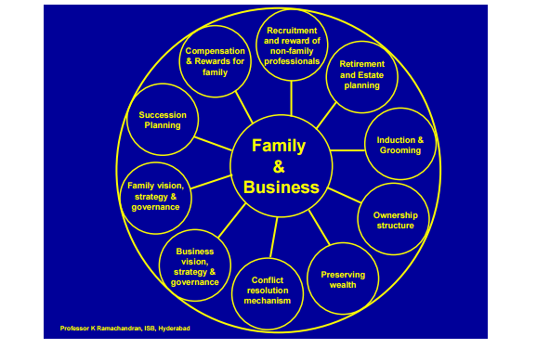
Figure 2 10 commandments of family Business
Source: (Ramachandran, 2006)
Talking about the distinctive features of family owned business, Epperlein (2010) advocated that the focus of family members are on the long term goals and not only quarterly results. In addition to this, they have the chances of creating a culture where all personnel feel more enthusiastic to the same cause and the business obliges to preserve domestic ties from one age band to another. In the same year, Caspar et al. (2010) cited about five characteristics of the family business which are family, possession, management of wealth, bases, commercial and portfolio administration. It was discovered that only those corporate that master the happenstances intrinsic to this form of proprietorship withstand and prosper over the generations.
Like Epperlein (2010), Pelligana (2011) also highlighted on the competitive advantage that family business relish over others. Furthermore, the report also presented that members of a family in business have a tendency to display a superior sense of loyalty to each other and to the trade.
In a report by Sapovadia (2012), advantages of family owned business were underlined. Alike Ramachandran (2006), this report also explicated that there is robust association amongst the members of a family and they share vigorous bond built on their mutual principles.
However, in the UK, it was found that one of the renowned family owned business is of Cadbury (London Economics, 2011). It was also highlighted that despite the prominence of family business as a mode for systematising manufacturing in many nations across the globe, the existence of individual family business is always ambiguous even if, as an organisation, the family business will expect to remain for a long time a significant characteristic of several manufacturing and developing economies.
In one of the study carried out in UK by Bournemouth University Business School (1999) as mentioned in London Economics (2011), it was found that only 30% of UK family business efficaciously pass into the hands of the next generation of the instituting people. However, this figure drops noticeably over succeeding generations, with only 13% of UK family business forwarding effectively to the fourth generation. Lastly, it has also been remarked that family businesses, in spite of using a longer-term forecasting prospect than non-family run business, may expend an uneven amount of time and drive vexing to acquire long-run regulation over the trade through placing relatives in strategic executive positions and eventually transferring the trade into the governance of the succeeding generation. Binder Hamlyn (1994) in London Economics (2011) discovers substantiation to propose that longer-term progress in family run business is repeatedly foregone in support of holding such regulation, and that non-family run business in the UK are more expected to presume to upsurge their market share equated with family business.

2.3 Need for Succession Planning and Factors influencing Succession Planning in Family Run Businesses
Succession planning in any business signifies recognising and polishing people to substitute the person in highest or crucial positions (Fager & McKinney, 2007). It is the tactical practise for any organization’s endurance and achievement. However, it is found that in India firms are more reactive than proactive in this respect.
The National Academy of Public Administration (NAPA) in Anavesh (2011) defined succession management as “a deliberate and systematic effort to project leadership requirements, identify a pool of high potential candidates, develop leadership competencies in those candidates through intentional learning experiences, and select leaders from among the pool of potential leaders”. Succession Planning is very important and the following studies show the importance of the planning in a family owned business.
Highlighting about the prominence of succession planning, Mehrabani & Mohamad (2011) explicated that enduring and bourgeoning in the existing challenging environment necessitate revising of succession planning and supervision in the establishments by executives before reactively upgrading or discarding staff. As succession planning and administration is a procedure and a scheme, like any other human resource undertakings it need to be appropriately executed in business establishments.
In family run business, the majority of the stake or ownership remains with the members of the family. However, conflicts may arise as the roles of various members overlap each other. This may even lead to rivalry among the members proving to be detrimental of the business as a whole. It was found that succession planning is fruitful basically for the large organisations (Heinrichs, 2014)
Moroever, Sharma (2004) mentioned in Michel & Kammerlander (2015) that succession is very essential in context of accurate timing, hunting for the appropriate successor and implementing the succession procedure.
While running any business in this contemporary environment, it is vital for an organisation to be professional and adaptable. Assessment centres must be employed for setting clear path by the businesses that are being run by family. This also aid in selection of potential successor for crucial position in the organisation (Pattnayak, 2014).
In the above discussion, a brief was presented pertaining to the need and prominence of succession planning. However, there are certain factors that influence succession planning in family owned business. These factors can be classified as family factors, business factors and individual factors.
There is a famous saying about the business that ‘First generation creates, the second inherits, and the third destroys’ (Jain, 2006). He also added that the intensifying size of the family has an adversative bearing on health of the family business. Moreover, the process of succession becomes intricate if there are more numeral of potential family heirs. For instance, in India, the parsis like Tatas, Godrejs and Wadias have managed to endure for more than a century as the size of their families was limited.
Gupta et al. (2007) also presented his opinion pertaining to the succession planning stating that there are certain factors whose impact vary from one family to another. He further listed out those factors as discussed below.
- The health and scope of the business.
- The over-all commercial and corporate environment at the time of succession.
- Individual and business taxation concerns of the diverse options.
- The obtainability of prospective family and non-family successors.
They further added that a business can go for either pure family management or non-family managers or mixed management team. It is also imperative to consider all the stakeholder during the course of succession planning. The synchronisation of the family and its primacies, brotherly rivalry, generation gap and the suitable time of transition are some of the aspects that impact the succession planning.
In the same year, Fager & McKinney (2007) felt that succession planning should be initiated early as things may alter and the executives at the key positions should not wait till his stepping down age to discover a successor. One should also look into the talents required for successor.
A few years later, Foltz & Marshall (2012) explored the least debated arena, the cultural variables that impact particularly the father-daughter succession in family business. The societal and ethnic framework that connects to the role and anticipations of females in business and in the family impacts the role of daughters in family business succession strategy. It has been observed that there has been a mounting cultural recognition of female in key leadership roles on succession in past 20 years.
In broad spectrum, Wee & Ibrahim (2012) recapitulates the Morris, William and Nel’s famous list of elements swaying the family business move in three groups as stated below:
- Ground work of heirs – This entails the formal education, training, awareness, work experience, impetus, and inclination of the successor.
- Affiliation amid family members – This factor encompasses belief, interaction, principles and tradition, obligation and faithfulness that create a constructive environment whereas family chaos, mistrustfulness, clash, sibling rivalry generate an undesirable environment.
- Succession Knowledge – This entail whether it is smooth and comfortable or complex or aggressive one.

2.4 Competency vs. relationship in succession
A report by Glynn (2012) explicated that ownership and administration may changeover at various stages. In some occasions, while proprietorship may move to family, at an administration level, the shift is to those entities most proficient of handling the business, be they family or non-family personnel. However, it was also found that all the stakeholder are concerned about the change in ownership and the management as it ultimately impacts their own position. Thus, it is imperative to recognise prospective leadership replacements using core capabilities as an agenda.
In the same year, Yordanova (2012) also gave due weightage to competency while selecting a successor in a family owned business. Ibrahim et al. (2004) in Yordanova (2012) ascertained capability to lead, decision-making skills and proficiencies, and inclination and assurance of successor as the three crucial factors for a heir to take over the family trade and to undertake a headship role.
Samei & Feyzbakhsh (2015) also found the effectiveness of identifying the competencies permitting a successor to cultivate commercial entrepreneurship in a family owned business.
Subsequently Ghee et al. (2015) also discovered that lack of competency and ability to run a business efficiently is one of the major issues and concern connected with succession. This shows the prominence of competency which family owned business look into their successor. They further added that appropriate decisions can be taken by the competent successor.
A year later, Adedare et al. (2017) also articulated that experienced and high performing personnel, regardless of being a family or non-family individual should be chosen as the successor. This is because experience and trained personnel can lessen the chance of let-down when one generation prospers the next.
While all the above scholars gave their opinion about the prominence of competency while selecting a successor, there are only few who gave due weightage to the relationship while transferring the ownership position (Lumpkin et al., 2008). A healthy family relationship may prosper a business while vice versa may lead to failure and conflicts. Thus, while selecting a successor from the member of a family, various elements such as harmony in relations, family cohesion and adaptability must be borne in mind as this all have bearing on the business performance.
Bocatto et al. (2010) elucidated that there is dearth of research work that explored the association between pre-performance and succession. In this regard, they explicated that former firm performance may sway the recommendation of a family or a non-family associate to top high-ranking designations. It was further argued that optimistic business performance will result in the nomination of a family member, while undesirable business performance will result in non-family recommendations.
Maciel et al. (2015) talked about the influence of family relationship in succession planning. They further added that though such associations add to the progress and expansion of the complete system, they can also create abrasion, clashes, and breakage. Because of the nature of a family commerce, the family repercussions institutes one of the greatest dominant elements in the intricacy of its administration. This is so as the family can have a strategic impact on both the structural and tactical enactment as family fellows can enforce their principles, intents and judgements. They also propounded that succession planning largely depends upon the characteristics of the family and the business which it owns.

2.5 Role of managers in family business success/ profitability
Managers have a crucial role to play in success of every business. In fact, operations and profitability of the business largely depends upon the efficiency of the managers. In this respect, Vadnjal & Zupan (2009) explicated the role-played women managers in flourishing the business. The stated that in many instances these women managers offer highly valuable input and efficiently conduct the business.
Husain (2013) talked about the prominence of effective communication skills of the manager. He further added that interpersonal skills within an organization are projected to have a vital effect on the extent to which personnel rely their managers and the establishment’s top rank, as well as their obligation to the business. Moreover, the most key conclusion extracted was that the achievement of the distribution and adaptation of organizational change considerably depend upon interactive and instructive abilities of managers at all levels. This helps in drawing with a conclusion that an effective organisational change with provide conducive environment to the employees leading to the growth of the company.
Cross cultural skills of the manager are also fundamental for the success of an organisation as denoted by Sornalatha et al. (2014). The knowledge of language and culture by a manager of different countries helps in fetching business opportunities. This also helps in motivating the employees of the organisation. As a manager of a multi-cultural and global team of individuals, understanding of their philosophy, their customers and the mode of performing business activities is a key to success of a business.
Sidek & Mohamad (2014) analysed the relationship between the managerial skills and growth of small business. They stated that effective managerial skills are not only vital for multinational organisations but also for small firms. The progression of small business largely depends upon the conceptual, technical and generic skills of the manager. Moreover, it was also argued that several management scholars and experts consider that the managers should master a combination of rudimentary skills in order to perform their parts successfully in business. Moreover, managers cannot effectually plan, guide, regulate, or evaluate work activities without these elementary abilities.
López-Cabarcos et al. (2015) pointed out that managers make strategic selections such as the choice of resources and merchandises, the business’s position in the marketplace, the level of expansion, the structural layout, and the management profile. These selections donate to the success or failure of the business. In addition to this, selection of an appropriate approach also rest upon the technical, marketing and organisational competencies of a manager. The coordination and interaction of the manager with the resources of the organisation also play crucial role in effective functioning of the operation of the business leading to growth.
In the above section, a brief idea was presented pertaining to the role of managers in success and profitability of the business. It was found that effective managerial skills are imperative for achieving organisational objectives.

2.5 Chapter Summary
In this chapter, a detailed review of literature is delineated which is primarily a compilation of numerous discoveries by varying researchers in stances related to evaluation of two companies and comparison between them with special reference to competency of family members and profitability of business. The review offers for an academic framework to indubitably pick up the need and prominence of succession planning to handle the matters arising in management of family owned business. With an increase in globalization, many family owned business find it problematic to handle the routine affairs of the business. Moreover, the young generation frequently find it challenging and hesitate to take the challenges and step up to take ingenuities. The prominence of non-family members was also highlighted to achieve the organisational goals. Moreover, succession planning was offered as a way out to manage the challenges successfully.
The study focussed on the prominence of the competency of the successor. It was revealed that a successor should be competent enough to handle the business crises. Moreover, the role of family relation in succession planning was also discussed. It was found that though members of the family believe in the growth and development of business yet family relations may also sometimes lead to conflict and clashes leading to decline in profitability of the business.
However, after reviewing the available literature it was found that though extensive research has been done on succession planning and family business, yet the studies failed to point out two major answers which formulate the research questions for this study:
- Which factor should be more important Competency or Relationship in planning succession?
- Should companies select a successor from the family or to hire a person from outside the family and its impact on the profitability of the business?
The present study is thus an endeavour to fill this research gap.

Chapter 3: Research Methodology

3.1 Chapter Introduction
In order to pursue an eminent research study, it is significant to define research methodology in clear and precise terms (Adams et al., 2014). Though this section of the study an effort is made to throw light on differing aspects of the methodology that has been adopted for successfully meeting the objectives of this study. The chapter is further segregated into differing sub-sections where research philosophy, approach, strategy, sampling, data collection and analysis, ethical issues and limitations associated with this research study are discussed.

3.2 Research Philosophy, Approach and Strategy

3.2.1 Philosophy
It is with the help of an appropriate research philosophy that a researcher is in a position to carry out a research study effectively. The 4 research philosophies that a research can be based upon are positivism, pragmatism, interpretivism and realism (Saunders et al., 2009).
This study which is undertaken based upon interpretivism research philosophy aims to fill up the gap prevailing in existing literature and thereby adding worth. The study has sought details with regards to family business and the role of managers in the same by making a comparative analysis between India and the UK. The goal being to find whether managerial posts in family business are inherited based on competencies or relationships, the study explores information to find answers to the same. The study is developed on the basis of pivotal viewpoints highlighting the deployment of interpretivism philosophy.

3.2.2 Approach
A research study can be undertaken using a deductive approach or an inductive one. This decision helps in setting the research technique that will lay the foundation for overall study. Considering that the study is based on a sequential methodology wherein information about family business and whether competencies are more important or relationships is being explored, it matches to the norms of inductive approach (Gratton & Jones, 2010). This particular study to meet its objectives first explores theories and literature on family business which are subsequently examined through primary information collected from real world companies operating as family business.

3.2.3 Strategy
The research strategy adopted for this study is a mixed one wherein both the quantitative and qualitative strategies are amalgamated to derive concrete results through a comprehensive study (Creswell, 2013). By deploying quantitative strategy, it is possible to use statistical tools and techniques for data collection and analysis. On the other hand, qualitative analysis makes it possible to collect in-depth information that is subjective in nature which can be analysed in a descriptive manner by deriving common themes. The results derived using a mixed approach are helpful in generating holistic perspective. The study put forwards perspectives of employees and managers of family business which depicts the thoughts of both employers and employees.

3.3 Sampling, Data Collection and Analysis

3.3.1 Sampling
Sampling technique for this study has been different for both the types of data that is quantitative and qualitative. The quantitative data has been collected through a survey which required collecting information from employees. Considering the fact that both companies are large scale companies operating across borders collection of information from the entire population would not have been possible (Lim & Ting, 2013). Thus, snowball sampling (non-probabilistic) approach was adopted in which references of other employees who can become a part of this study were put forward as recommendations (Landy & Conte, 2010). The details of referenced respondents were first collected by sending questionnaire to first 25 employees and then questionnaire was sent to them.
The second sampling technique that has been adopted for collection of qualitative information through interviews is convenience sampling (non-probabilistic) approach. This assisted in collecting information from managers who were not a part of the family hierarchy but also were readily available to be a part of this study.

3.3.2 Data Collection
The study used both primary data and secondary data to achieve its objectives (Bechhofer & Paterson, 2012). The secondary data has been collected from available literature and critically reviewed in the prior chapter. The significant sources for secondary information for this study have been reports, conference proceedings, journal articles, books and webpages (Saunders et al., 2009).
The primary information has been collected from two differing sources to meet the requirements of qualitative and quantitative strategies (Sapsford & Jup, 2006). A survey of 100 employees (50 from each company) has been undertaken using a close-ended questionnaire (structure in nature) for collecting quantitative information (Sapsford & Jup, 2006). 57 people belonging to lower management levels from each company were mailed the questionnaire and from them first 50 respondents with duly completed survey questionnaire were selected. The details like email ids of these employees were collected through organisational websites and social media. Once positive response was availed from few responses they were asked to provide for details of other who might be interested in the study (as a part of snowball sampling). For a sample size to be normally distributed a minimum of 30 sample size is required (Smith, 2013). Considering the fact that both the companies are large scale companies a size of 30 respondents would have been very small. Further to conduct a valid and reliable analysis considering the limitations of this study it was determined that 50 respondents would be chosen. 7 extra respondents were sent the questionnaire to keep a margin for errors and non-replies.
Information was collected within a period of 5 working days excluding the day when the questionnaire was mailed that is 1st Aug 2017. Interview of 2 managers from middle and upper level of management belonging to the family group (1 from each company) has been undertaken using an open-ended interview schedule (semi-structured in nature) (Bechhofer & Paterson, 2012). The employees were essentially non-family members and thus for interviews family members were chosen in order to comprehend information from a different perspective. The details of these managers were procured from the organisational website and they were sent emails seeking permission for interviews. Once consent was availed the interviews were conducted online through Skype for a period of 2 hours and the information was transcribed.

3.3.3 Data Analysis
As two types of data are collected using two differing tools, analysis of these data will also be done using two differing techniques. The quantitative information has been analysed using SPSS using statistical tools like cross tabulations, regression and correlations. Cross tabulations will assist in comparing the responses provided by both the participants from India and the UK. The data reliability was tested using Cronbach Alpha. The qualitative data has been analysed descriptively.

3.4 Ethical Issues and Limitations

3.4.1 Ethical Aspects
The following ethical considerations have been taken care of while developing this research study:
- The respondents were made aware about the research objectives and other related details thus maintaining transparency with regards to study purpose
- The respondents were endowed with freedom to consent and freedom to walk out from the study as and when they wanted to
- Forceful data collection was strictly prohibited thus respondents shared data at their will
- The secondary data has been acknowledged throughout the study
- Manipulation of information both primary and secondary has been completely restricted.

3.4.2 Limitations
The study has restricted implications owing to below identified reasons:
- Choosing 50 respondents from each company formulate a very small sample size considering the enormous size and scale of sample companies. This restricts possibilities of extrapolation of information
- The study is chastely undertaken for academic purposes and thus has been subjected to limited resources
- The findings cannot be generalised for other companies hailing from nations other than India and the UK. But then the findings can be applicable to organisations subjected to similar environment (both internal and external). The findings will also assist family organisations in designing appropriate success plans for their organisations.

3.5 Chapter Summary
The clear outlining of research methodology thus supports progressing with the research study in a lucid manner. This research methodology directs data collection and analysis which has been undertaken in the next chapter.

Chapter 4: Data Analysis

4.1 Chapter Introduction
In this chapter, the primary information collected from differing levels of management comprising managers and employees belonging to both family and non-family categories from both the companies has been analysed. The information has been segmented into two categories quantitative (survey response analysis) and qualitative (interview analysis).

4.2 Quantitative Analysis
The information is collected using the Likert Scale with 5 points and analysed using SPSS software. Statistical tools like frequency analysis, cross tabulations and correlation-regression analysis has been undertaken to achieve research objectives. The information is presented with the help of tables and graphs along with their interpretations.

4.2.1 Reliability Test
The reliability of responses is checked using the Cronbach Alpha which establishes the internal consistency of data and responses. A higher alpha denotes higher levels of consistency. The Cronbach Alpha value of this study is depicted in table below:
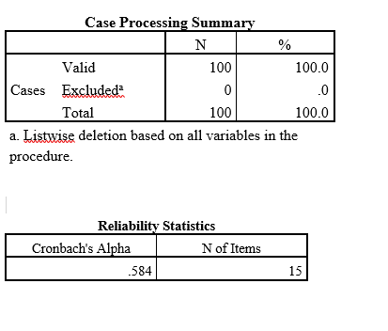
Table 1 Reliability Tests

Table 1 highlights Cronbach’s alpha’s value that is 0.58 for 15 items which is considered to be a higher one (Glynn, 2009). Thus, further proceedings in form of data analysis and its interpretation can be carried out. The data is not higher than 0.60 (which is considered to be an ideal situation) it has variables that are multi-dimensional in nature (Glynn, 2009).

4.3.2 Demographic Analysis
Age Analysis
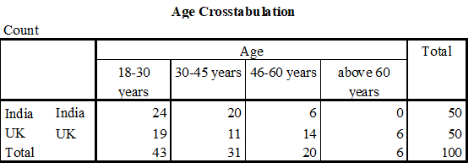
Table 2 Age Analysis
The table 3 depicts age group of respondents belonging from India and the UK. It can be inferred that majority of respondents in both the nations belong to the youth category that is 18-30 years. However, a major difference in seen in the 46-60 years and above age of employees as a larger section of employees in UK belong to this section when compared to India. Thus, it can be delineated that India has a more youth employed population whereas in the UK it is the combination of youth and elderly. The information is depicted graphically below:
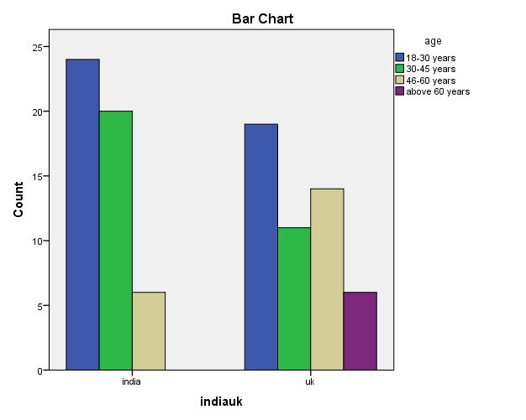
Figure 3 Age Analysis

Gender Analysis

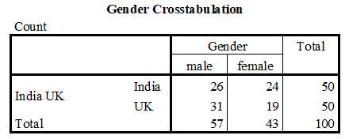
Table 3 Gender Analysis

The table 4 depicting cross-tabulations between India and the UK highlight that in both the nations it is the male that dominate the employment within the family business quotient. In India though the difference between male-female employment is lower that is 26:24 which depicts and increasing number of women being a part of corporate world. For the UK, considering that the nation is highly developed the gulf between male and female that is 31:19 is very high. The information is depicted graphically below:
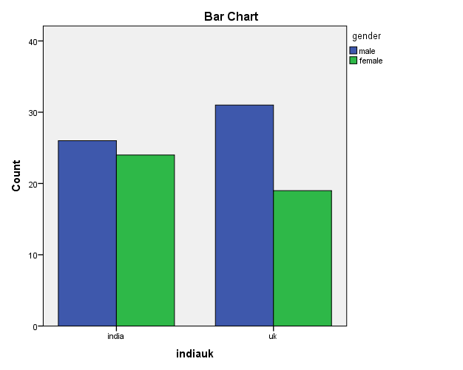
Figure 4 Gender Analysis
Experience within the Company Analysis

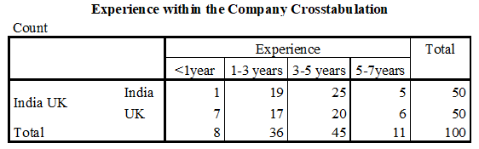
Table 4 Experience within the Company Analysis
The table 5 depicting respondent’s association with the company denotes that majority of them both from India (50% respondents) and the UK (40% respondents) had an experience within the company of 3-5 years followed by those having an experience of 1-3 years (38% in India and 34% in the UK). In India employees having experiences less than a year was very low that is 2% as compared to 14% in the case of the UK. The information is depicted graphically below:

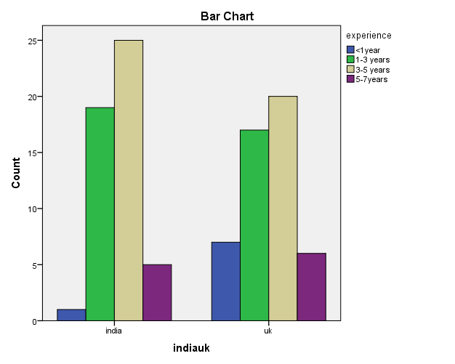
Figure 5 Experience within the Company Analysis

4.3.3. Company Overview
Top Management Composition

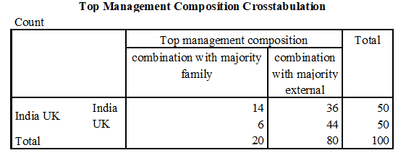
Table 5 Top Management Composition
The table 6 highlights that in India and the UK all the respondents unanimously considered that the top management is composed of both family members and external members. However, 72% respondents from India and 88% respondents from the UK agreed that the top management comprised of more external members in comparison to family ones. The information is depicted graphically below:
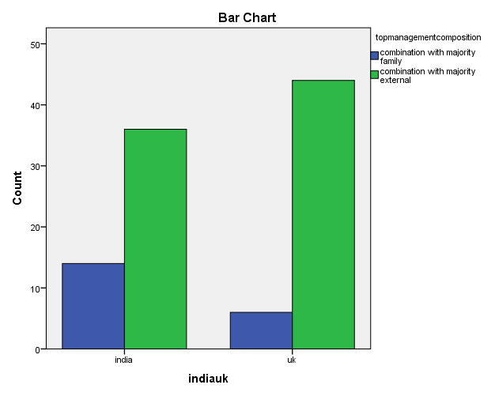
Figure 6 Top Management Composition
Educational Qualification for being a manager within the company

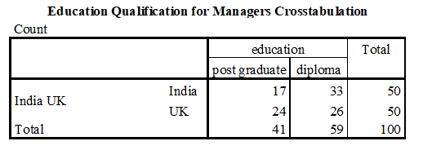
Table 6Educational Qualification of Managers
As per the above table 7 all the respondents agreed that the managerial posts essentially required a minimum qualification of post-graduation (34% respondents in India and 48% respondents in the UK) or diploma (66% respondents in India and 52% respondents in the UK). Graduation was not considered for these posts. The information is depicted graphically below:
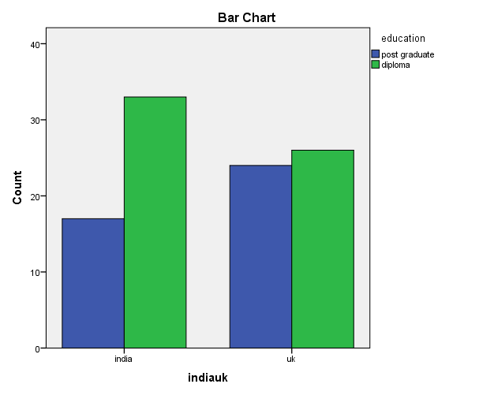
Figure 7 Educational Qualification of Managers

4.3.4 Competency Vs. Relationship
The top management is dominated by family members to ensure continuance and succession across generations

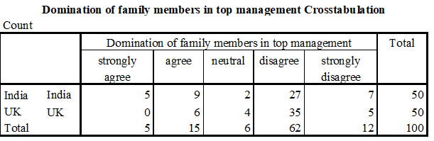
Table 7 Domination of Family Members in Top Management
The table 8 overhead outlines that a majority of respondents from both India and the UK disagreed to the statement “The top management is dominated by family members to ensure continuance and succession across generations”. In India 14% strongly disagreed and 54% disagreed whereas in the UK it was 10% strongly disagreed and 70% disagreed to it. The information is depicted graphically below:
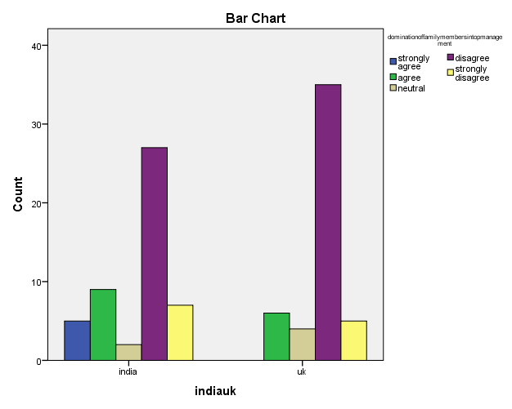
Figure 8 Domination of Family Members in Top Management

The decision making is decentralised thus motivating external members to take part in decision making and have a fare succession planning

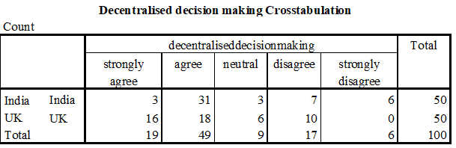
Table 8 Decentralised Decision Making

The table 9 overhead outlines that a majority of respondents from both India and the UK agreed to the statement on decentralisation of decision making which gives a chance to external members. In India 6% strongly agreed and 62% agreed whereas in the UK it was 32% strongly agreed and 36% agreed to it. This can be related to the above statement wherein external member participation in the top management is allowed in the case of both the companies. The information is depicted graphically below:
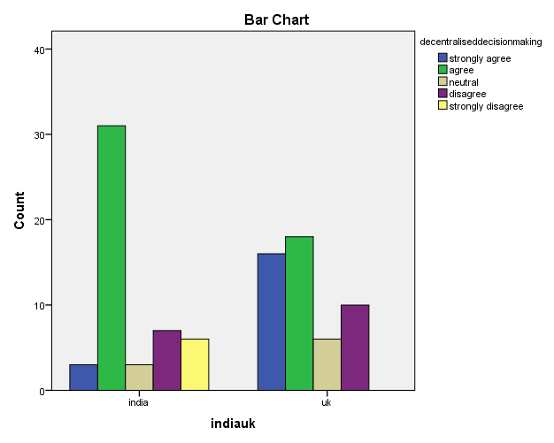
Figure 9 Decentralised Decision Making

The organisational structure supports succession based on competency rather than relationships (competencies over relationships)

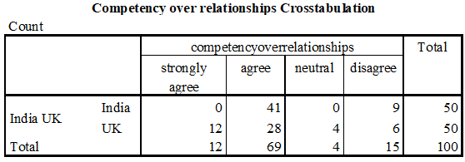
Table 9 Competency Over Relationships
The table 10 overhead outlines that a majority of respondents from both India and the UK agreed to the statement on preference for competency over relationships. In India 82% agreed whereas in the UK it was 24% strongly agreed and 56% agreed to it. These competencies can however be related to family members or non-family ones. The information is depicted graphically below:

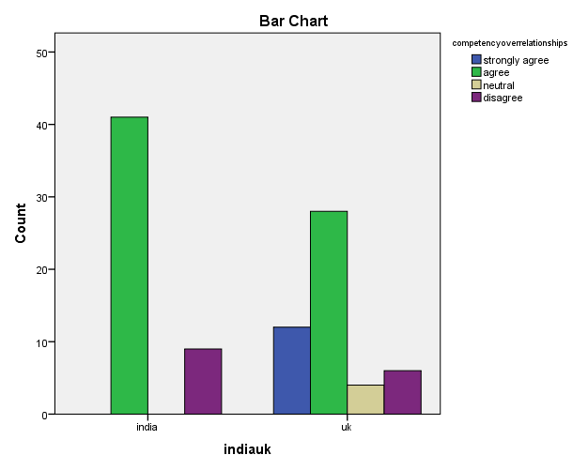
Figure 10 Competency Over Relationships
The family members dominate the succession planning process (relationships over competencies)

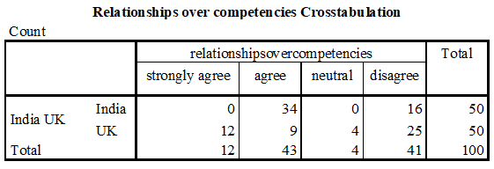
Table 10 Relationships Over Competencies
The table 11 overhead outlines that a majority of respondents from both India and agreed to the statement relationships are also importance and given preference over competencies. In India 68% agreed. Considering the case of the UK 24% strongly agreed and 18 % agreed to it whereas 25% disagreed to it. The responses provided by the respondents is contradictory as on had they believe competencies are opted over relationships as seen in prior sections whereas here they consider relationships to be more important than competencies. The information is depicted graphically below:

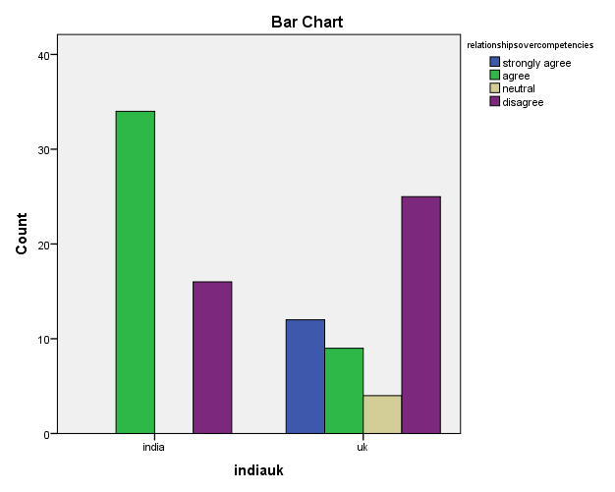
Figure 11 Relationships Over Competencies
The organisation supports development of external employees’ competencies to make them able successors

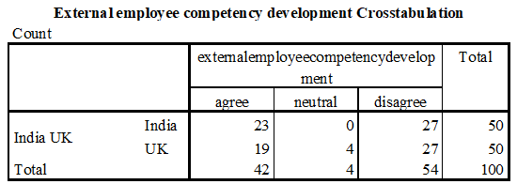
Table 11 External Employee Competency Development

The table 12 overhead outlines that a majority of respondents from both India and the UK disagreed to the statement competency development of external members as a part of succession planning in family business. In India and the UK, 54% in each country disagreed. However, the difference between those who agreed and those disagreed is very minimal as in India 46% respondents were for the statement and in the UK it was 38%. It is evident that most of the employees are not sure about the succession planning process adopted within their organisation. It might be due to lack of appropriate communication between stakeholders or inappropriate policies towards succession planning. The information is depicted graphically below:
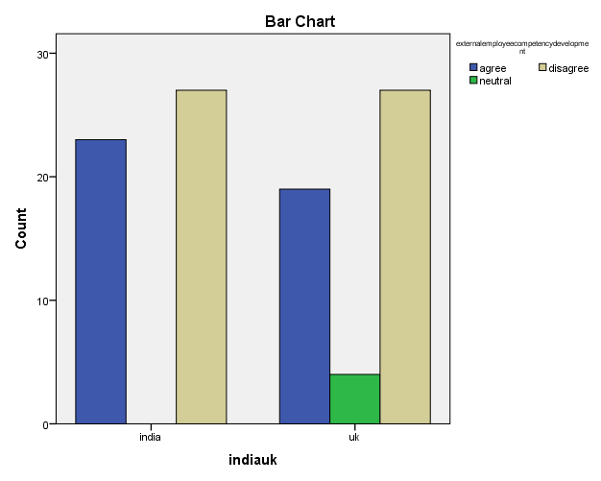

Figure 12 External Employee Competency Development
Family members are educated and competencies developed to make them able successors

Family member competency development Crosstabulation
Count
 |  | familymembercompetencydevelopment |  |  | Total
 |  | agree | neutral | disagree
India UK | India | 23 | 0 | 27 | 50
 | UK | 19 | 4 | 27 | 50
Total |  | 42 | 4 | 54 | 100
Table 12 Family Member Competency Development
The table 13 overhead outlines that a majority of respondents from both India and the UK disagreed to the statement competency development of family members as a part of succession planning in family business. In India and the UK, 54% in each country disagreed. However, the difference between those who agreed and those disagreed is very minimal as in India 46% respondents were for the statement and in the UK, it was 38%. This further confirms that there is no appropriate succession planning defined by these family organisations. Even if it is defined the employees are not aware of the same as can be inferred from primary information. The information is depicted graphically below:

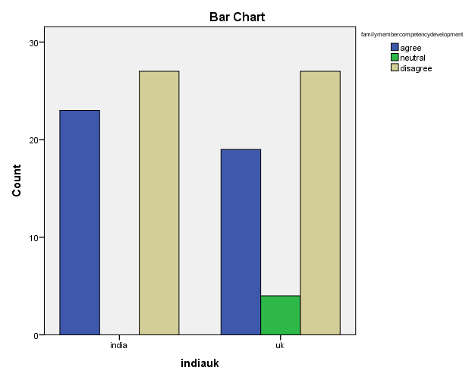
Figure 13 Family Member Competency Development

The family plays a dominant role in organisational leadership

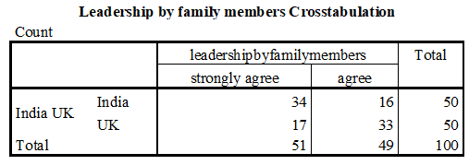
Table 13 Leadership by Family Members
All the respondents from India and the UK unanimously agreed that in family business organisation to which they are associated with family members play a dominant role in organisational leadership as seen in table 14 above. In India 68% respondents strongly agreed and 32% agreed whereas in the UK it was 34% strongly agreed and 66% agreed to it. Thus, it can be inferred that in India family members dominance is higher as compared to that in the UK. The information is depicted graphically below:
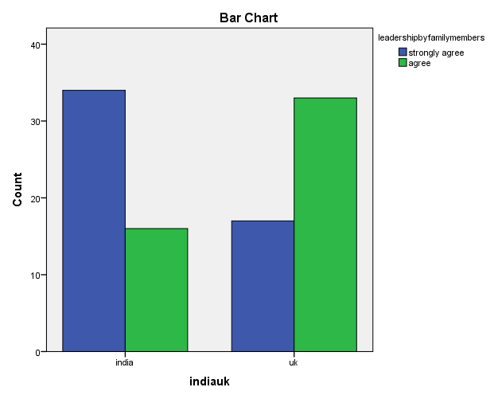
Figure 14 Leadership by Family Members

The succession plan supports organisational success and profitability

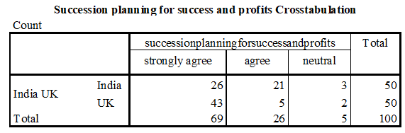
Table 14 Succession Planning for Profits and Success
The unanimous response of the respondents whether from the UK or India was in favour of succession planning as seen in table 15 above. They all considered it to be related to organisational long run success and profits. In India 62% respondents strongly agreed and 42% agreed whereas in the UK it was 46% strongly agreed and 10% agreed to it. Although the respondents are not aware much about succession planning within their organisation but they are sure about the benefits the company can receive through appropriate succession planning. The information is depicted graphically below:
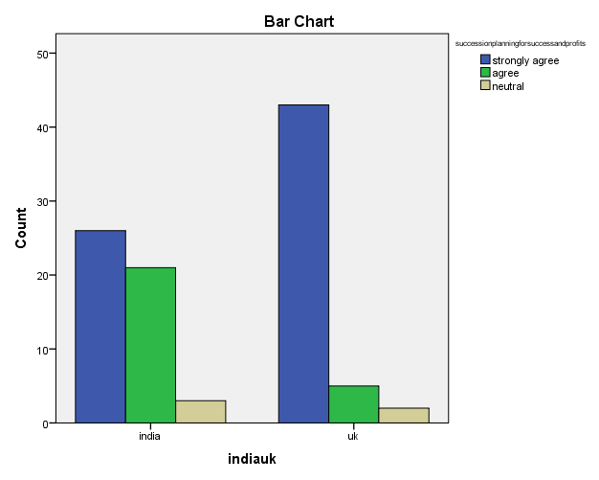
Figure 15 Succession Planning for Profits and Success

4.3.5 Recommendations and other comments
Suggestions for supporting business profitability and success in long run

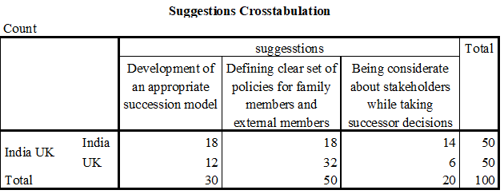
Table 15 Suggestions
Out of 4 options provided to the respondents none opted for “Considering both educational qualification and experience while developing successors” as seen in Table 16 above. Equal significance in India has been given to definition of appropriate policies for family and external members as well as development of an appropriate succession model with 36% respondents option for each option. This was followed by 48% respondents who opted for consideration of stakeholders while taking succession decision. However, in the UK, majority that is 64% wanted clear rules for family and external members, followed by 24 % who wanted an appropriate succession model and finally 12 % who wanted consideration of stakeholders. The information is depicted graphically below:
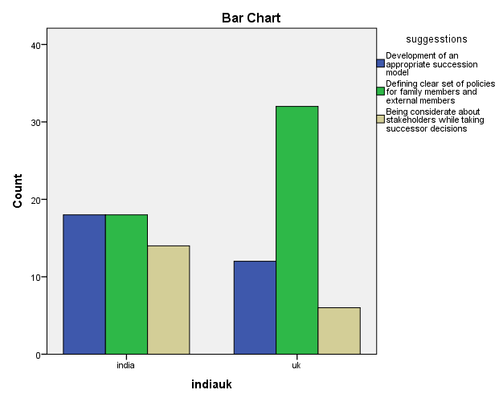
Figure 16 Suggestions

4.3.6 Inferential Analysis
This section of the analysis chapter identified as inferential analysis is designed to identify answers to research questions identified in the introduction and literature review section. The research questions were:
- Which factor should be more important competency or relationship in planning succession?
- Should companies select a successor from the family or to hire a person from outside the family and its impact on the profitability of the business?
These research questions are answered by performing analysis using correlation and regression on questionnaire information collected through surveys. As this study is about comparative analysis between family business in India and the UK the most important variable that is taken into account is India and the UK. The research questions tests whether competency or relationship is considered to be important in the case of Indian family business and in the case of UK’s family business. Further the analysis also tests whether companies opt for selection of successor from within the family to have a positive impact on organisational profitability and success.

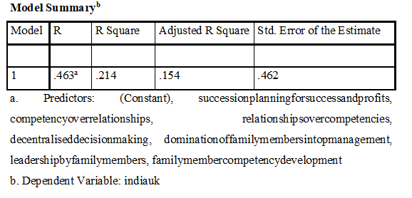
Table 16 Model Summary
The table 17 above depicting the Model Summary of the regression was developed on the basis of correlation. In this case India and the UK are considered to be dependent variables whereas as Competency Vs. Relationship factors are considered to be independent variables. The independent variables are
- The top management is dominated by family members to ensure continuance and succession across generations
- The decision making is decentralised thus motivating external members to take part in decision making and have a fare succession planning
- The organisational structure supports succession based on competency rather than relationships (competencies over relationships)
- The family members dominate the succession planning process (relationships over competencies)
- The organisation supports development of external employees’ competencies to make them able successors
- Family members are educated and competencies developed to make them able successors
- The family plays a dominant role in organisational leadership
- The succession plan supports organisational success and profitability
The above table 17 depicts the findings from regression. The adjusted R square value in accordance to the table is 0.154 which denotes a difference of 15% between India and the UK and respondent’s perception about competency vs. relationships within the family business in which they are employed. Further the value of R square is 0.214 which is considerably far from 1. Thus, it can be inferred that this equation of regression is not very significant to be used for forecasting.
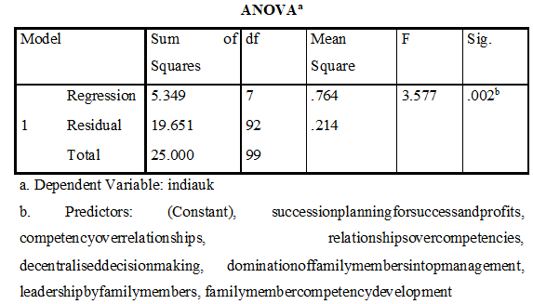
Table 17 Anova Table
The table 18 above which is the ANOVA table highlights the F value and the related significance. For this study F = 3.577 having significance at p = .002. This is an indicator of lower variation of 15% and thus can be considered as a primary reason as to absence of differences in the thoughts of employees from India and the UK with regards to competency vs. relationship in succession planning in family business organisations.

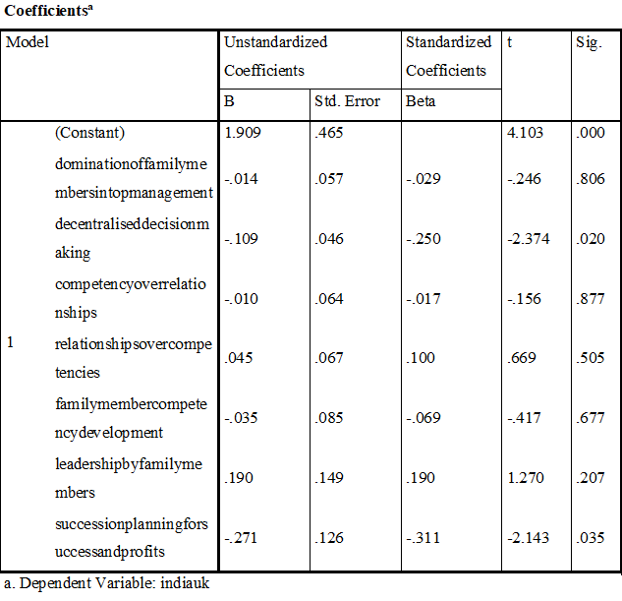
Table 18 Coefficient Table
From the above table 19 that is the Coefficient Table it can be inferred that preference of family business towards relationships over competencies and retaining leadership positions by family members to a larger extent has a bearing on succession planning in family businesses in India and the UK. For relationships over competencies t = .669 and p = .505 and leadership by family members t = 1.270 and p = .207 are the primary factors influencing succession planning in family businesses in both the nations that are India and the UK. The value of significance for this is 1% that is 0.01.
In this analysis one of the variables that is external employee competency development for succession planning has been excluded from being subjected to regression analysis by SPSS as shown in table 20. One of the primary reasons for this is erratic and unhinged estimations of regression coefficients.

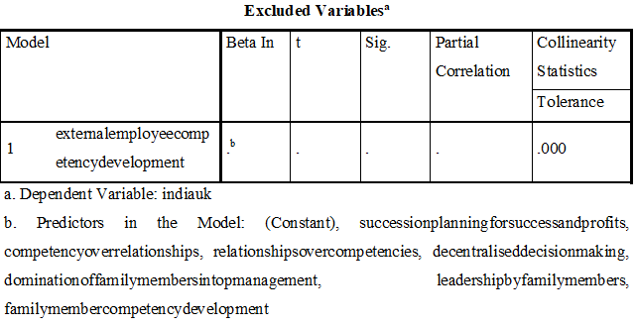
Table 19 Excluded Variables
From the above analysis, it can be derived that in both the companies that hailing from India and the other from the UK, relationships are given importance over competencies for the higher-level posts especially those related to top management and leadership. It can also be inferred that companies have appropriate approached through which they train the family members to take up the succession plan. As such development programs for external members have been excluded from regression analysis it cannot be commented upon. Considering that the companies have been performing well under the leadership of family members the family business should continue to select and train such people as a part of their succession plans.

4.3 Qualitative Analysis
The information is collected using the interview schedule from the family members at managerial position of case companies that is Reliance and Swire Group is analysed in this section. 1 manager from each company has been chose. The analysis is being done using descriptive analysis by drawing common themes. The primary themes are namely, competency vs. relationships and successorship for family members for ensuring organisational success and profitability.
In order to ensure that the ethical considerations of confidentiality are maintained the names of the respondents has been codified into A and B. The basic details about the respondents is provided in table below:
Sr. No. | Name | Country | Gender | Designation | Experience | Family Generation
1. | A | India | Male | Senior Manager | 5-10 years | 3rd Generation
2. | B | The UK | Male | Senior Manager | 5-10 years | 3rd Generation

Table 20 Manager Respondent Profile

4.3.1 Theme 1: Competency Vs. Relationship
On questions related to competency versus relationships both the respondents notified that competency was given an upper-hand within their organisation.
In words of Mr. A, “We are a large company and it would have been impossible to reach this stage if we focused only on relationships. Competencies are indispensable and thus we ensure that right job is performed by the right person irrespective of him being a family member or a non-family member. As a part of Reliance, we are already a 1 big family”. Similar opinions were also voiced by Mr. B to further added that “We aim to be successful and consider organisational interests to be important over others. Thus, undoubtedly competency is more important than relationships”.
However, both Mr. A and Mr. B were of similar opinion with regards to employment of family members. They both stated that as the business belongs to the family, such members would be in a better position to look after the jobs considering it a part of family prestige. They both also accepted the significance of external members within the company to gain from diverse pool of talents.

4.3.2 Theme 2: Successorship for family members for ensuring organisational success and profitability
Mr. A said that “We have a succession plan in place which has been followed since a long time and it has been embedded within the company. The plan focuses on talent and not on relationships thus ensuring that organisational success and profits are given more importance over personal benefits”. Mr. A further admitted that though the company gave more importance to competencies but yet family members formed an integral part of the company. The family members since their childhood are groomed to be a part of the family business for which the top management and leadership positions are retained by them through majority shareholding.
Mr. B quoted that “To be honest we do not have any appropriate succession plan within our organisation. It is the organisational policy that supports organisational success and profits. The human resource policy supports overall organisational policy”. Mr. B further accepted that family member should be given importance over external members. He suggested that the company should have a proper succession planning process in accordance to which the family members must be groomed and thus absorbed within the group for long run sustainability of the organisation.
From the responses of both the representatives, it can be further derived that the family members are officially introduced and hired by the organisation. In India as identified there are appropriate measures like internship and training for such introduction which results in further hiring whereas in the UK there is no such measure. The company policies are equal for all and no special mechanisms is espoused upon to hire family members. The competency development program as inferred from responses was present in form of basic training and development. As both the organisations lacked appropriate succession planning such strategies were not vividly adopted. In absence of such strategies having different approaches for family and non-family members was difficult to determine.

4.4 Chapter Summary
The data presented above provides for the opinion of both family and non-family members thus depicting a comprehensive picture. The analysis of primary information has been very helpful in gaining an understanding of secondary information collected and presented in earlier chapters. The discussions are outlined in the following chapter along with the recommendations designed on the basis of analysis undertaken.

Chapter 5: Discussions, Conclusions and Recommendations

5.1 Chapter Introduction
The chapter provides for a summary to the overall research study and thus delineates important findings which are discussed. Further a set of recommendations is developed considering the findings to assist family business with better approach regarding human resource management thereby supporting then to pursue business in the long run in a profitable manner.

5.2 Discussions and Conclusion
Objective 1: To understand the essential features of the family business with reference to India and UK.
From the analysis of primary and secondary data it has been understood that there is not much difference in the characteristics family business in India and the UK. From the primary data, it has been delineated that in both the nations there is no appropriate succession plan and further family members are given importance. But along with family members competency of people within the organisation also plays a dominant role within the organisation. In both the nation top management position though has a composition of both family and non-family members but yet the leadership positions are essentially retained by family members.
Objective 2: To comprehend the factors influencing Succession Planning in Family Run Businesses.
From the analysis of primary data, it was determined that in both the nations the family run business lacked appropriate succession planning which was as a matter of fact a major reason of chaos and issues within an organisation. There is a difference of opinion between family and non-family members. For example, in accordance to family members competencies are given priority over relationships but as per the non-family members it is vice-versa. The most important factors identified from primary and secondary data influencing succession planning are organisational policies.
Objective 3: To compare and contrast and competency and relationship in succession planning.
In both primary and secondary information collected both the elements that are relationships and competency are found to be important elements in succession planning. Family run business developed competencies in their family members and thus placed them in dignified position especially those present in leadership and top management levels. In both the case companies’ appropriate competency development program for non-family members was missing. Further it was also delineated that family business in totality lacked a formal approach towards succession planning and thus provision of appropriate comparison of both these aspects was not possible.
Objective 4: To assess the role of managers in the family business.
In secondary data, the managers were found to be playing indispensable role in the success of family business. From the primary data though it is difficult to derive this directly it was found that considering the success of business over the years it is the managers that have been playing a strong role towards achievement of organisational vision.

5.3 Recommendations
Based on the analysis and findings from both primary and secondary information the following recommendations are put forward for family run business in India and the UK:
- Succession Plan: It is highly recommended that family business should have succession plans and policies in place. An appropriate succession plan will also assist in balancing between competencies and relationships. A pre-defined succession plan will make sure that all the norms and approaches are appropriately determined thus raising the confidence of non-family members within the organisation by making them open to equal opportunities. It will also provide clear guidelines to family members as to what course of action to resort to in order to be a part of the family business on the basis of merit and competencies rather than mere relationships. This will in the long run also assist the family business to be sustainable as well as be successful and profitable.
- Competency Development Programs: The family business should organise competency development programs on a regular basis for both family and non-family members. It will ensure that the organisation is operating on fair grounds. It will also establish that organisational vision is considered to be of primary significance as competency programs will focus on its achievement rather than family and non-family factors resulting in minimisation of friction between the two.

5.4 Chapter Summary and Scope for Future Research
The current study clearly explored the approach towards competencies and relationships especially when related to succession planning within a family business in the context of India and the UK. It has been determined that there is a lack of proper succession planning within such types of business formats both in the UK and India. Thus further studies can be carried out in determining approaches that might be adopted to design an appropriate succession plan. Also, comparative analysis between family business within 1 nation can be undertaken to derive a comprehensive picture.

Annexure

Annexure 1: Quantitative Questionnaire
Section A: Demographic Profile
Age:
- 18-30 years
- 30-45 years
- 45- 60 years
- 60 years and above
Gender:
- Male
- Female
Experience within the Organisation:
- Less than 1 year
- 1-3 years
- 3- 5 years
- 5-7 years
- Above 7 years
Section B: Company Overview
Q.1 Top Management Composition
- All Family members
- All external Members
- Combination of the two with majority family members
- Combination of the two with majority external members
Q. 2 Educational Qualification for being a manager within the company
- Graduate
- Post-Graduation
- Diploma

Section C: Competency Vs. Relationship
Q.1 Rate the following questions on a scale of 1-5 where 1= strongly agree, 2= agree, 3= neutral, 4= disagree, and 5= strongly disagree
Statement | 1 | 2 | 3 | 4 | 5
The top management is dominated by family members to ensure continuance and succession across generations
The decision making is decentralised thus motivating external members to take part in decision making and have a fare succession planning
The organisational structure supports succession based on competency rather than relationships (competencies over relationships)
The family members dominate the succession planning process (relationships over competencies)
The organisation supports development of external employees’ competencies to make them able successors
Family members are educated and competencies developed to make them able successors
The family plays a dominant role in organisational leadership
The succession plan supports organisational success and profitability
Section D: Recommendations and other comments
Q.1 Suggestions for supporting business profitability and success in long run
- Development of an appropriate succession model
- Defining clear set of policies for family members and external members
- Being considerate about stakeholders while taking successor decisions
- Considering both educational qualification and experience while developing successors
- Others (please outline)....................................................................
Other Comments if any:
___________________________________________________________________________
Thank you for your time!!

Annexure 2: Interview Schedule
Designation: .............................................................................................................
Years of Experience:
- from 0 to 5 years
- from 5 to 10 years
- from 10 to 15 years
- more than 15 years
Family Generation:
- 1st generation
- 2nd generation
- 3rd generation
- 4th generation
Questions
- Is there any succession plan within the organisation?
- How are family members hired / recruited? Does the organisation has a defined policy format for introducing family members within the organisation? Please elaborate.
- According to you what is more important for the sustainability of this business relationship or competency or both?
- Is there any competency development strategy within the organisation? Is it same for all (family and non-family members)? Please elaborate.
- Would you like to change existing approach of the company towards competencies and relationship? If yes then how (suggestions)?

References
Axiom . (2012). Management Challenges Facing the Family Business and How Great Families Conquer Them. Austin: Axiom Consulting Partners, LLC.
Adams, J., Khan, H., & Raeside, R. (2014). Research Methods for Business and Social Science Students (2nd ed.). London: SAGE Publications.
Adedare, S., Rasheed, O., & Muideen, O. (2017). Executive Competency and Sustainability of Family-Owned Enterprises in Lagos and Ogun States Nigeria. Imperial Journal of Interdisciplinary Research, 3(2), 192-197.
Anavesh, N. (2011). A Study on Sucessfull Planning and its Impact on Organizational Performance in Information Technology Sector. Journal of Arts, Science & Commerceommerce, II(1), 1–12.
Aronoff, C., McClure, S., & Ward, J. (2016). Family Business Compensation. New York: Springer.
Bechhofer, F., & Paterson, L. (2012). Principles of Research Design in the Social Sciences. London: Routledge.
Bocatto, E., Gispert, C., & Rialp, J. (2010). Family‐Owned Business Succession: The Influence of Pre‐performance in the Nomination of Family and Nonfamily Members: Evidence from Spanish Firms. Journal of Small Business Management, 48(4), 497-523.
Campopiano, G., De Massis, A., & Cassia, L. (2014). Corporate social responsibility in family versus non-family enterprises: An exploratory study. In A. Lundström, C. ‎Zhou, & Y. Friedrichs, Social Entrepreneurship (pp. 113-154). Berlin: Springer International Publishing.
Cappelli, P., Singh, H., Singh, J., & Useem, M. (2015). Indian business leadership: Broad mission and creative value. The Leadership Quarterly, 26(1), 7-12.
Caspar, C., Dias, A., & Elstrodt, H. (2010). The five attributes of enduring family businesses. London: McKinsey & Company.
CGMA. (2012). Managing the challenges of family businesses. Retrieved Aug 23, 2017, from CGMA: http://www.cgma.org/Resources/Reports/DownloadableDocuments/family-owned-business.pdf
Creswell, J. (2013). Research Design: Qualitative, Quantitative, and Mixed Methods Approaches (4th ed.). London: SAGE Publications.
Epperlein, P. (2010). Family-Owned & Consultant Businesses The Executive Search. London: InterSearch.
Fager, M., & McKinney, D. (2007). Succession Planning for the Family Owned Business. London: Lulu.com.
FFI. (2016). Global Data Points. Retrieved Aug 23, 2017, from Family Firm Institute: http://www.ffi.org/page/globaldatapoints
Foltz, R., & Marshall, M. (2012). Family Business Decision-Making: Factors and Influences on Choosing a Successor. Agricultural & Applied Economics Association’s 2012 AAEA Annual Meeting. Seattle: Agricultural & Applied Economics Association.
Ghee, W., Ibrahim, M., & Abdul-Halim, H. (2015). Family Business Succession Planning: Unleashing the Key Factors of Business Performance. Asian Academy of Management Journal, 20(2).
Glynn, M. (2009). Business-to-business Brand Management: Theory, Research and Executive Case Study Exercises (Vol-15). Bingley: Emerald Group Publishing.
Glynn, N. (2012). Ownership and management transition in a family business. Dublin: Deloitte.
Gratton, C., & Jones, I. (2010). Research Methods for Sports Studies (2nd ed.). Oxon: Taylor & Francis.
Gulzar, M., & Wang, Z. (2010). Corporate Governance and Non-Listed Family Owned Businesses: An Evidence from Pakistan. International Journal of Innovation, Management and Technology, 1(2), 124–129.
Gupta, P., Jain, R., & Dhar, U. (2007). Enhancing enterprise competitiveness: (marketing, people, IT and entrepreneurship) . Ahmedabad: Allied Publishers.
Heinrichs, K. (2014). Succession in Family Businesses: An In-Depth Qualitative Study of Succession in German Family-Owned Wineries. London: Books on Demand.
Husain, Z. (2013). Effective communication brings successful organizational change. The Business & Management Review, 3(2), 43-50.
Jain, R. (2006). Chains that Liberate, Governance of Family Ties. New Delhi: Macmillan.
Landy, F., & Conte, J. (2010). Work in the 21st Century: An Introduction to Industrial and Organizational Psychology (3rd ed.). London: John Wiley & Sons.
Lim, W., & Ting, D. (2013). Research Methodology: A Toolkit of Sampling and Data Analysis Techniques for Quantitative Research. Norderstedt: GRIN Verlag.
London Economics. (2011). Family businesses: do they perform better? Dublin: European Foundation for the Improvement of Living and Working Conditions.
López-Cabarcos, M., Göttling-Oliveira-Monteiro, S., & Vázquez-Rodríguez, P. (2015). Organizational capabilities and profitability: The mediating role of business strategy. SAGE Open, 5(4).
Lumpkin, G., Martin, W., & Vaughn, M. (2008). Family Orientation: Individual-Level Influences on Family Firm Outcomes. Family Business Review, 21(2), 127-`38.
Maciel, A., Ramos, M., Aguilar, J., & Reyna, J. (2015). The influence of family relationships in the succession: A factorial analysis of Mexican enterprises. 5(2), 238-256.
Mehrabani, S., & Mohamad, N. (2011). Succession Planning: A Necessary Process in Today’s Organisation. International Journal of e-Education, e-Business, e-Management and e-Learning, 1(5), 371-377.
Michel, A., & Kammerlander, N. (2015). Trusted Advisors in a Family Business’s Succession-Planning Process—An Agency Perspective. Journal of family business, 6(1), 45–57.
OECD. (2007). Governance challenges For Family-owned businesses. OECD: Suzano.
Pattnayak, B. (2014). Human Resource Management (4th ed.). Delhi: PHI Learning.
Pelligana, D. (2011). The Competitive Advantage of a Family Business, Available at https://www.kpmg.com/TT/en/IssuesAndInsights/ArticlesPublications/Documents/Family Business Competitive Advantage.pdf . Sydney: KPMG.
PWC. (2013). Family firm The India perspective . New Delhi: PriceWaterHouse Coopers.
Ramachandran, K. (2006). Indian family business: Their survival beyond three generations. ,. Hyderabad.: Indian School Business.
Samei, H., & Feyzbakhsh, A. (2015). A Framework of Successor Competencies to Promote Corporate Entrepreneurship in Family Firms. Journal of Enterprising Culture, 23(3), 321-355.
Sapovadia, V. (2012). Corporate Governance Issues in Indian Family-Based Businesses. Munich: MPRA.
Sapsford, R., & Jup, V. (2006). Data Collection and Analysis (2nd ed.). London: SAGE Publications.
Saunders, M., Lewis, P., & Thornhill, A. (2009). Research Methods for Business Students (5th ed.). London: Financial Times Prentice Hall.
Sidek, S., & Mohamad, M. (2014). Managerial competencies and small business growth: empirical evidence from microfinance participants. International Journal of Management Sciences, 21(1), 39-59.
Smith, D. (2013). Reliability, Maintainability and Risk: Practical Methods for Engineers (4th Ed.). Oxford: Elsevier.
Sornalatha, P., Daisy, B., & Pushpam, V. (2014). A Study on Cross Culture Skills in Management. IOSR Journal of Business and Management, 1, 63-65.
Vadnjal, J., & Zupan, B. (2009). The role of women in family businesses. Economic and Business Review for Central and South-Eastern Europe, 11(2), 159.
Wee, Y., & Ibrahim, M. (2012). Family Business Success Factors: Management Practices, Relationship Among Members and Succession Experience. International Journal of Arts & Commerce, 1(6), 274.
Yadav, P., & Singh, J. (2013). Family Owned Businesses: Issues Relating To Succession Planning. 3rd Biennial Conference of the Indian Academy of Management . Ahmedabad: Indian Academy of Management (IAM).
Yordanova, D. (2012). Development and selection of successors in family firms: Evidence from Bulgaria. Annual book of Sofia University “St. Kliment Ohridski", 10, 91-103.

